EXP:1
Implement a C Program for Reversing a 32 bit signed integers
AIM:
To write a C program to reverse a 32-bit signed integer.
ALGORITHM:
- Read integer n
- Extract last digit using n%10
- Build reverse using rev = rev*10 + digit
- Repeat until n becomes 0 and print rev
PROGRAM:
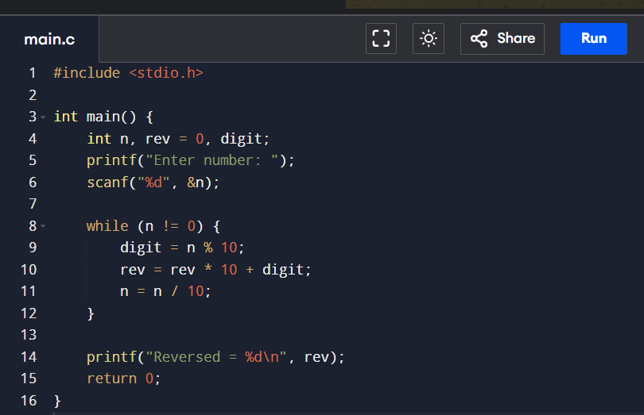
OUTPUT:
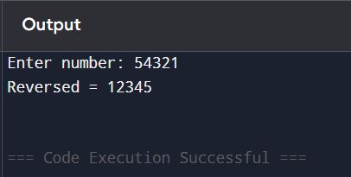
RESULT:
The program successfully reverses a 32-bit signed integer.

